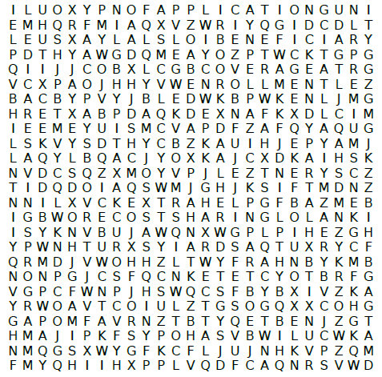
Word Bank
Premiums | Part A | Beneficiary
Copays | Part B | Enrollment
Cost Sharing | Application | Coverage
Extra Help | Deductible | Medicare Savings Program

Inset Logo Here
Need help with Medicare or healthcare costs? Contact:
Agency Name
Agency Phone Number

